**COLLEGE OF BUSINESS EDUCATION**



**DODOMA CAMPUS**

*Student’s Name:* **FRANK MALENGO**

Reg no: **03.8102.01.02.2022**

***Course* : BIT**

***Lecturer*:madam ATUPELE CAIRO MWAITETE**

***Subject:* PROGRAMMING IN JAVA**

***Nature of Work:* INDIVIDUAL ASSIGNMENT**

**Question.**

You are required to create a small Java application that addresses an everyday challenge faced by individuals or communities in Tanzania with a theme of **"Digital Solutions for Everyday Challenges in Tanzania"**. Each student should select a specific challenge and provide a software-based solution.

**Library Management System using Java GUI**

**1. Project Overview**

The Library Management System is a desktop application designed to streamline library operations using Java Swing for the graphical user interface. The system offers essential features like adding books, issuing books, returning books, and viewing the book catalog in a user-friendly manner. This project demonstrates how Java Swing can be used to create an intuitive interface for managing library operations efficiently.

**2. Objectives**

* To create a user-friendly application to manage library books.
* To provide functionalities such as adding, issuing, returning, and viewing books.
* To use Java Swing for the graphical interface and Java collections for backend data management.

**3. Key Features**

1. **Add Book**:
   * Allows the librarian to add new books by entering the title and author.
   * Provides input validation to ensure all necessary details are entered.
2. **Issue Book**:
   * Enables the librarian to issue a book to a user.
   * Ensures a book is not already issued before issuing it.
3. **Return Book**:
   * Allows the librarian to mark a previously issued book as returned.
4. **View Books**:
   * Displays the list of books in a tabular format, including their title, author, and issued status.

**4. Implementation Details**

**4.1 Technologies Used**

* **Programming Language**: Java
* **GUI Framework**: Java Swing
* **Development Environment**: IntelliJ IDEA / Eclipse / NetBeans
* **Backend**: Java Collections (ArrayList) for book storage.

**4.2 Code Structure**

1. **Book Class**:
   * Represents a book with attributes: title, author, and isIssued.
   * Methods: getTitle(), getAuthor(), isIssued(), issue(), and returnBook().
2. **LibraryManagementGUI Class**:
   * Manages the GUI and application logic.
   * Contains methods for each functionality:
     + addBook(): Adds books to the collection.
     + issueBook(): Marks a book as issued.
     + returnBook(): Marks a book as returned.
     + viewBooks(): Displays the list of books in a JTable.

**5. Screenshots**

1. **Main Interface**:
   * Displays buttons for all key functionalities: Add Book, Issue Book, Return Book, View Books.
2. **Add Book Dialog**:
   * Input fields for book title and author.
3. **Issued and Returned Status**:
   * Displays the updated status of books in the table.

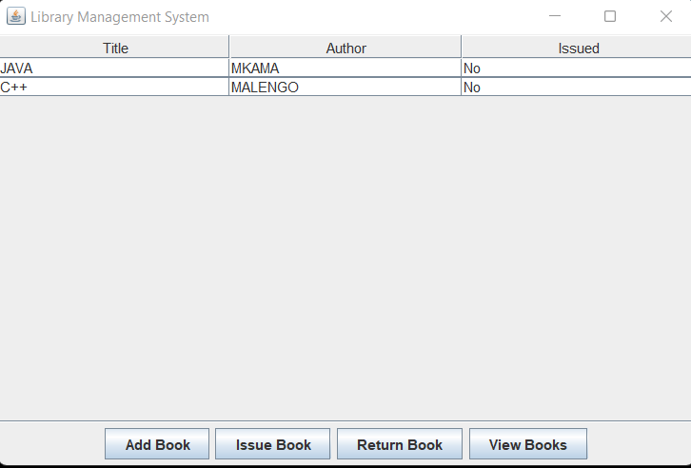

**6. Challenges Faced**

1. **Ensuring Input Validation**:
   * Challenge: Handling cases where the user enters invalid or incomplete data.
   * Solution: Used dialogs to prompt the user for valid input and provided feedback for errors.
2. **Dynamic Updates to JTable**:
   * Challenge: Updating the JTable dynamically after adding, issuing, or returning books.
   * Solution: Used DefaultTableModel to manage table data and refresh the view whenever changes were made.
3. **Error Handling for Book Operations**:
   * Challenge: Preventing the issuance or return of non-existent or already issued/returned books.
   * Solution: Added checks before performing each operation and provided appropriate feedback.

**7. Results**

The Library Management System successfully:

* Simplifies library management with an intuitive GUI.
* Provides reliable and efficient operations like adding, issuing, returning, and viewing books.
* Demonstrates the integration of backend logic with frontend GUI using Java Swing.

**8. Future Enhancements**

1. **Member Management**:
   * Add functionality to manage library members and track which member issued which book.
2. **Search and Filter**:
   * Implement search and filter options for better book catalog management.
3. **Database Integration**:
   * Store book and member details in a database like MySQL or SQLite for persistent storage.
4. **Advanced GUI**:
   * Use JavaFX for a modern and responsive interface.

**9. Conclusion**

The Library Management System demonstrates the power of Java Swing in creating effective desktop applications. It is a practical solution for small libraries and can be further enhanced with additional features for scalability and efficiency.